**Seasonal Dynamics of an Emerging African Malaria Vector, *Anopheles stephensi*: Implications for Malaria Control**

Charles Whittaker1*, Ellie Sherrard-Smith1, Peter Winskill1, Gina Cuomo-Dannenburg1, Patrick G.T. Walker1, Marianne Sinka2, Samuel Pironon3, Ashwani Kumar3, Azra Ghani1, Samir Bhatt1,4, Thomas Churcher1 & Arran Hamlet1

1MRC Centre for Global Infectious Disease Analysis & Abdul Latif Jameel Institute for Disease and Emergency Analytics, School of Public Health, Imperial College London, London, UK

2Department of Zoology, University of Oxford, Oxford, UK

3Biodiversity Informatics and Spatial Analysis Department, Royal Botanic Gardens Kew, Richmond, Surrey, UK

4Vector Control Research Centre, Indira Nagar, Puducherry, India

5Section of Epidemiology, Department of Public Health, University of Copenhagen, Copenhagen, Denmark

**\*Corresponding Author:** Charles Whittaker, Department of Infectious Disease Epidemiology, School of Public Health, Imperial College, London W2 1PG, United Kingdom. Email: [charles.whittaker16@imperial.ac.uk](mailto:charles.whittaker16@imperial.ac.uk)

**Keywords:** *Anopheles stephensi*; malaria ecology; urban malaria; population dynamics; seasonality; epidemiology.

**Abstract**

Increasing urbanisation has contributed to reductions in malaria burden across sub-Saharan Africa with urban areas typically experiencing lower levels of transmission. Recent invasion and proliferation of the urban malaria vector *Anopheles stephensi* across the Horn of Africa threatens this progress. Understanding the vector’s seasonal dynamics in these settings represents a crucial input to its control, given that mosquito seasonality shapes the temporal profile of malaria risk, and in turn which interventions will be most effective. Here we collate longitudinal catch-data for the species from across South Asia and the Middle East to better understand these dynamics and explore their implications for malaria transmission in urban settings across the Horn of Africa where the disease is currently largely absent. Our analyses reveal pronounced variation across *Anopheles stephensi* populations in the extent and timing of seasonality, ranging from single, highly seasonal peaks to bimodality and near-perennial patterns of annual abundance. We show that this diversity is underpinned by different patterns of land use, as well as variation in seasonal patterns of rainfall and temperature across locations. Dynamics frequently differ between rural and urban settings, suggesting structural differences in how these environments shape patterns of vector abundance. Integrating these seasonal profiles with a model of malaria transmission, we show that the impact of IRS is highest in settings with the highest seasonality, but that crucially, achieving this impact requires an understanding of when *Anopheles stephensi* populations are likely to peak. Our results highlight a critical need to better understand the vector’s temporal dynamics across the Horn of Africa, but also a lack of studies from the region able to directly inform these questions, underscoring the need for longitudinal entomological monitoring of the vector across the region.

**Introduction**

With an estimated 241 million cases and over 600,000 deaths across endemic countries in 20201, malaria represents one of the most significant infection diseases globally2. Burden of disease is concentrated in sub-Saharan Africa where an estimated 96% of malaria deaths in 2020 occurred – 80% of these in children under 53. This represents an almost 40% reduction in clinical disease since the year 2000, an achievement underpinned predominantly by significant scale-up of control interventions including insecticide-treated bednets4.

Alongside this significant expansion of control efforts, increasing urbanisation of Africa’s populace (rising from 31% to 43% between 1990 and 2018, with over 60% expected to live in urban areas by 20505) is also thought to have indirectly contributed to reductions in disease burden. Previous work has highlighted significantly lower annual Entomological Inoculation Rates (EIR) in urban compared to rural settings6,7, a finding thought to be underpinned by features factors including systematic differences in the quality of housing8,9, reduced availability and suitability of habitats for *Anopheline* breeding in urban settings10–12, better access to treatment13, and higher population densities leading to higher human to mosquito ratios (and reduced transmission)14. Whilst these trends are not always consistently identified (see e.g. surveys in Libreville, Gabon15 or Cotonou, Benin16 where prevalence of malaria is higher in urban areas than immediately surrounding locations; or previous work highlighting that *Anopheles gambiae s.s.* can adapt to breeding in polluted water characteristic of urban environment17), increasing urbanicity across sub-Saharan Africa is likely to complement planned scale-up of malaria control interventions aimed at achieving the targets outlined in the World Health Organization’s 2030 Global Technical Strategy for Malaria18.

This potential positive impact of increasing urbanization is contingent on urban settings across the continent remaining areas of comparatively low malaria transmission. This phenomenon is currently under threat by the invasion and establishment of the malaria vector *Anopheles stephensi*. Found throughout South Asia, there are three known forms *Anopheles stephensi* – “type”, “intermediate” and “mysorensis”. The mysorensis form is predominantly found in rural settings, and possesses a low vectorial capacity (due to its zoophilic behaviour19), although several studies have documented it as able to sustain some level of transmission across these settings20. The type and intermediate forms representing highly efficient vectors capable of transmitting both *Plasmodium falciparum* and *Plasmodium vivax* parasites across both urban and rural settings, although it is its ability to proliferate in urban locations that distinguishes this species from other dominant malaria vectors in the region. This efficiency as an ubran vector is thought to be underpinned by both an increased tolerance for breeding in polluted water sources21, and a superior ability to access and utilise the manmade hydrological habitats present in urban settings22,23. The species was first identified in sub-Saharan Africa in Djibouti City in 201224 and has since been recorded in both Ethiopia25,26 and Sudan27,28, with recent work highlighting likely suitability for the species across some of the continents largest population centres comprising over 100 million people29. Whilst causality has yet to be conclusively established, its emergence is thought to have contributed to the significant resurgence of malaria transmission in Djibouti (which experienced a 10-fold increase in cases between 2013 and 2019), highlighting the potential threat establishment of this vector poses to malaria control across the Horn of Africa30, as well as wider efforts across the continent31.

The situation in Djibouti, as well as recent modelling work suggesting *Anopheles* *stephensi*’s establishment in Ethiopia could lead to a 50% increase in malaria incidence30, highlights the significant public-health threat the vector poses. Despite this, substantial uncertainty remains how its future expansion and establishment might influence malaria in the region, particularly in the (predominantly urban) settings where the disease is currently largely absent. A key driver of this will be the seasonal patterns of abundance by *Anopheles stephensi*. Mosquito populations are highly temporally dynamic, often exhibiting substantial annual fluctuations in size that drive the temporal profile of disease risk. Understanding the factors underlying these dynamics is crucial given that the effectiveness of many malaria control interventions (such as seasonal malaria chemoprevention32 or indoor-residual spraying33) depends on the timing of their delivery relative to seasonal peaks in transmission. A better understanding of *Anopheles stephensi*’s seasonal dynamics is therefore likely to have material consequences for the effective control of malaria across the Horn of Africa.

Despite this relevance, substantial uncertainty remains regarding *Anopheles stephensi*’s seasonal dynamics; numerous studies carrying out longitudinal catches are present in in the literature, but these typically only focus on a single location, precluding systematic comparison and identification of generalisable patterns. Here we collate longitudinal mosquito catch data for *Anopheles stephensi* from 6 countries and 45 unique locations across South Asia, the Middle East and the Horn of Africa in order to better understand these dynamics, and the ecological factors underpinning them. Our results highlight pronounced variation in the extent and timing of seasonality, with distinct dynamics observed across rural and urban settings. Integrating these results with a model of malaria transmission highlights how this variation will influence the efficacy and impact of malaria control efforts in parts of the Horn of Africa where the disease is currently (or has previously been) largely absent and underscores the crucial, urgent need for rapid scaleup of entomological monitoring for this emerging urban vector across the region.

**Methods**

**Systematic Review of *Anopheles stephensi* Literature**

We collated references from published systematic reviews of literature relating to *Anopheles stephensi*29,34, and updated these previous searches (both conducted in 2017) by searching *Web of Science* and *PubMed* databases from January 2017 to September 2020 for further relevant references. We included all records containing temporally disaggregated adult mosquito catch data with monthly (or finer) temporal resolution spanning at least 10 months, that had not been conducted as part of vector control intervention trials, where sufficient information to geolocate the catch site to the administrative unit 2 level, and where a total of at least 25 *Anopheles stephensi* had been caught over the study period. Overall, a total of 36 references were collated containing 65 time-series from catch surveys carried out in distinct locations from across Afghanistan (n=2), Djibouti (n=1), India (n=32), Iran (n=17), Myanmar (n=5) and Pakistan (n=8). See **Supplementary Information** for further details.

**Gaussian Processing Fitting and Smoothing of Time Series Data**

Per previous work34, we fitted the following Gaussian Process-based model to smooth these noisy mosquito count time-series, using a Negative Binomial likelihood to account for overdispersion in the data:

where is a distribution over functions from a zero-mean Gaussian Process with covariance function , with the covariance between two timepoints and defined according to the kernel function . A periodic kernel function was used to capture the seasonally/annually repeating patterns often observed in mosquito populations, specified by the hyperparameters , and , where represents the period over which we would expect points to show similar dynamics (i.e. a period of twelve would imply we expect points separated by 12 months to be most similar), specifies the magnitude of the covariance, and  represents a lengthscale parameter further constraining the extent to which two values separated by a given time can co-vary. (x) are function evaluations at times , are the observed mosquito counts indexed by timepoint . Model fitting was carried out within a Bayesian framework, using the probabilistic programming language STAN35.

**Characterisation of Temporal Properties and Clustering of Similar Time-Series**

Based on previous work providing a framework to statistically characterise the empirical structure of time-series data36, we calculated a number of summary statistics for each smoothed time-series to characterise their temporal properties. These include the median of the period () from the gaussian process fitting, the relative entropy between the time-series and uniform distribution, the proportion of points in each smoothed time-series where the total catch was greater than 1.65x the mean, the difference in timing between the peak in vector density and the highest rainfall recorded in the location, the proportion of the total catch that was found in any 4 month period (in-keeping with previous definitions of malaria seasonality37), and then 3 features arising from fitting 1 and 2 component Von-Mises distributions (a continuous probability distribution representing the maximum entropy distribution for circular/repeating data) to the smoothed time-series. These 3 features were the mean of the 1 component Von-Mises distribution, the number of peaks (determined by comparing the quality of fit for 1 and 2 component Von-Mises distributions, roughly corresponding to asking whether assuming the time-series was unimodal or bimodal provided the best fit), and the weight (), specifying the comparative contributions of each component in the two-component fitting. See **Supplementary Information** for further details. From this, we obtain for each time-series a set of 7 real numbers providing a reduced representation of their temporal properties – to this, we then applied a Principal Components Analysis to identify a lower-dimensional representation of the structure present in the data amenable to visualisation and implemented k-means clustering to identify clusters of time-series with similar temporal properties.

**Random Forest Prediction of Cluster Membership**

For each of the 65 time-series, we extracted a suite of environmental variables derived from satellite data that together describe the ecological structure of the location the entomological survey was carried out in, including the *BioClimatic* variables (a suite of biological relevant covariates defined from monthly rainfall and temperature satellite data38) as well as measures of landcover and urbanicity amongst others (a complete list can be found in **Supplementary Table X**). These environmental variables were then used as predictors within a Random-Forest based classification framework aimed at predicting the cluster membership (i.e. the results of the k-means algorithm described above) of a given time-series – see **Supplementary Figure X** for the individual fitted profiles for each time-series)**.** These models were fitted using the software package *Ranger*39, implemented in the *tidymodels* framework for R40, with 6-fold cross-validation utilised to optimise hyperparameter combinations; presented results are based on averaging the results of 25 separate iterations of cross-validation and model fitting (to account for stochasticity in model fitting), and any predictions made using out-of-bag model estimates in all instances. There were significant imbalances in class size across the clusters considered, we carried out upsampling using the SMOTE (synthetic minority over-sampling technique41) algorithm (though results are also presented without upsampling). Further details on defining the outcome variable and the Random Forest modelling framework can be found in the **Supplementary Information**.

**Modelling *Anopheles stephensi*-Driven Malaria Dynamics and Control**

We integrated the temporal profiles of *Anopheles stephensi* abundance into a deterministic version of a well-established compartmental model of *Plasmodium falciparum* malaria transmission and disease42–44 to explore the implications of *Anopheles stephensi* establishment and seasonality on the dynamics of malaria transmission and control; with a focus on settings in the Horn of Africa where malaria is currently largely absent. In brief, the human population is split into either susceptible or infected individuals, with those infected either being asymptomatic, currently suffering from clinical disease, possessing a sub-microscopic infection, having been treated, or currently in a period of prophylaxis following treatment. Mosquito populations are divided according to different life-stages, with larvae, pupae and adults all simulated, and subdivided into either susceptible, exposed or infectious (after the extrinsic incubation period, EIP) classes. The model explicitly takes into account heterogeneity in transmission, age-dependent mosquito biting rates, and the acquisition of natural immunity following exposure. For the purposes of exploring the impact of *Anopheles stephensi*, we integrated the collated temporal profiles of mosquito abundance alongside estimates of *Anopheles stephensi* bionomics from the literature to explore the potential impact the vector could have on settings across the Horn of Africa where malaria is currently largely absent – specifically how variation in seasonality of the mosquito might influence the impact of indoor residual spraying (IRS), a key vector control intervention. Full details of the model can be found in **Supplementary Information**.

**Results**

**Extensive Diversity In Temporal Dynamics Across the Collated *Anopheles stephensi* Time-Series:** A total of 65 time-series from entomological studies across Afghanistan, Djibouti, India, Iran, Myanmar and Pakistan were identified (**Fig.1A)**. These noisy time-series were then smoothed using a negative binomial gaussian process-based framework (see **Fig.1B** for a single example time-series from each country, see **Supp Fig.1** for all individual time-series). Substantial variation in temporal dynamics was observed across the collated time-series in terms of the degree and timing of seasonality – this ranged from highly seasonal dynamics with a single, clear seasonal peak (e.g. as with Afghanistan example in **Fig.1B**) to more perennial patterns of abundance (see Pakistan example in **Fig.1B**) and even bimodal annual population dynamics with two peaks observed across the course of a single year (as with the Iran example in **Fig.1B**).

**Statistical Characterisation and Clustering of Temporal Properties Highlights Distinct Temporal Archetypes:** An array of summary statistics were calculated for each time series to characterise their temporal properties (see **Supplementary Methods *Time Series Characterisation and Analysis*** and **Supp Fig.2**). A reduced representation of this variation was then generated using principal components analysis (PCA) and the result then clustered using the k-means algorithm to cluster the time-series into discrete groups of time-series that all share similar temporal patterns. Our results highlight two distinct clusters of time-series, with each group characterised by distinct and different temporal patterns **(Fig. 2A)** and that differ in the extent and degree of their seasonality (here defined as the percentage of total vector density that occurs across any continuous 3-month period, **Fig. 2B**). Cluster 1 time-series typically had clear, single seasonal peaks and were more seasonal on average (57% of total vector density in a 3-month period) than Cluster 2 time-series, which had less seasonal (more perennial) patterns of annual abundance (average 36% vector density in any consecutive 3-month period), including time-series with two peaks across the course of a single year. These results were sensitive to our choice of the number of clusters the k-means algorithm was specified to identify – specifying 4 clusters instead of 2 resulted in further disaggregation of the 49 time-series in Cluster 1 into 3 separate clusters, each characterised by a single seasonal peak, but which differed in the timing of their seasonal peak relative to the timing of peaks in monthly rainfall (**Supp Fig 3**). Despite differing significantly in vector abundance seasonality **(Fig. 2C**, top panel, p<0.001**)**, there was no significant difference across the Cluster 1 and Cluster 2 time-series and their respective locations in terms of rainfall seasonality **(Fig. 2C**, bottom panel, p=0.59**)**. This suggests that the differences in vector seasonality across the two clusters was not being driven by differences in the timing and seasonality of rainfall across the surveyed locations.

**Random-Forest Modelling and Prediction of Seasonal Dynamics Highlights Urbanicity As a Key Driver:** In order to explore the ecological factors underpinning this observed variation in *Anopheles stephensi* seasonality, we fitted a random forest-based classification modelling framework to a suite of satellite-derived environmental covariates in order to predict cluster membership (either Cluster 1 or Cluster 2, as defined in **Fig 2)**. Due to the significant class size imbalance between Cluster 1 (n=49) and Cluster 2 (n=16), we up-sampled the Cluster 2 data using the smote algorithm in order to generate balanced class sizes. Model discriminative and predictive performance was good – across the 25 iterations of random forest model fitting carried out, the mean AUC was 0.89 (indicating good predictive performance, **Fig. 3A**) and on average, the model was able to correctly classify Cluster 1 time-series 83% of the time, and Cluster 2 time-series 85% of the time. Annual temperature seasonality and rainfall seasonality (both bioclimatic variables describing the extent of annual fluctuations in the two environmental quantities), population per square kilometre and a number of measures of landcover (specifically LC30 which corresponds to mosaic cropland/natural vegetation, and LC20 which corresponds to irrigated or post-flooding cropland) were all highly predictive of Cluster membership **(Fig. 3B)**. Areas with lower population density were more likely to belong to Cluster 2, as were areas with high values of LC20 (i.e. land predominantly occupied by irrigated or post-flooding cropland). By contrast, areas with high values of LC10 and LC30 (i.e. substantial fraction of land covered either rainfed cropland or a mosaic of cropland and natural vegetation) were more likely to belong to Cluster 1, as were areas in which rainfall was strongly seasonal (see **Supp Fig. 4** for the full array of partial dependence plots for all covariates used in the analysis).

Motivated by this strong association with population per square kilometre, we manually collated whether each time-series had been carried out in a rural or urban setting (as defined by the authors of each study) and examined the association between rurality/urbanicity and temporal dynamics **(Fig. 3C)**. There was a near-significant association with rurality/urbanicity and cluster membership (chi squared test, p=0.07) – of the 25 time-series from studies carried out in urban settings, a significant majority (n=22) were assigned to Cluster 1 (88%) and only 3 to Cluster 2 (12%). By contrast, time-series carried from rural locations were more evenly spread between the two clusters – of the 37 time-series from studies in rural settings, 24 were assigned to Cluster 1 (65%) and 13 assigned to Cluster 2 (35%).

These results are qualitatively robust to the up-sampling procedure that we applied. Model predictive performance and variable importance rankings were similar when no up-sampling was applied to the dataset (mean AUC of 0.81, still indicating good predictive performance, see **Supp Fig. 5** for the ROC and variable importance plots), though average predictive accuracy on Cluster 2 (50%) was significantly lower than predictive accuracy on Cluster 1 time-series (94%). Model performance and relative ranking variable importance ordering was similarly retained when fitting the model and explicitly holding out a small subset of the data to evaluate model performance (n=7 time-series, see **Supp Fig. 6** for both results with and without upsampling). Overall study catch size was highly variable between the studies **(Supp Fig 7)**, and whilst the median catch size across the two clusters did not differ (Moody’s Median Test, p=0.47, median Cluster 1 = 292, interquartile range Cluster 1 = 116-793, median Cluster 2 = 235, interquartile range Cluster 2 = 112-434), the mean catch size did differ (t-test, p=0.025, mean Cluster 1 = 876, mean Cluster 2 = 364). We therefore carried out an additional sensitivity analysis including study average monthly catch as a covariate in the random forest model (**Supp Fig 8)** – predictive performance and relative rankings of variable importance remained similar despite this addition. The ability of the model to predict seasonality (as measured by the percentage of total vector catch in any 3-month period) was more modest, although estimates were positively correlated (r = 0.43, see **Supp Fig. 9**), with various measures of landcover including LC10, LC20 and LC30, as well as temperature and rainfall seasonality all strongly associated predictors of seasonality, as in the classification modelling.

**Exploring Possible Seasonal Dynamics and Surveillance of *Anopheles stephensi* Across the Horn of Africa:** We next collated the same satellite-derived environmental covariates described above for countries across the Horn of Africa where *Anopheles stephensi* has been found. These covariates were then inputted into the trained random forest classification model to predict potential temporal dynamics (as denoted by Cluster membership) of *Anopheles stephensi* across the Horn of Africa region **(Fig. 4A)**. Our results highlight distinct geographical areas across the region considered more likely by the model to belong to Cluster 1 (more seasonal, **Fig. 4B**) and Cluster 2 (less seasonal), as well as substantial areas of significant uncertainty. We next asked what consequences this uncertainty about the degree and timing of *Anopheles stephensi* seasonality might have on entomological surveillance of the vector across the region. Specifically, what the probability of missing *Anopheles stephensi* in entomological catches might be as a function of the number of consecutive months sampled (with start month selected randomly i.e., assuming no knowledge of *Anopheles stephensi’s* temporal dynamics). Our results highlight that in instances where sites are sampled for a limited number of months, there is a significant risk of missing *Anopheles stephensi* – even at 5 months of consecutive entomological sampling ranging from X-Y% (mean Z%) for Cluster 1 time-series and A-C% (mean Y%) for Cluster 2 time-series, with the exact value dependent on the specific time-series (and *Anopheles stephensi* temporal profile) being considered **(Fig. 4C)**. Our results highlight that in the absence of a detailed understanding of *Anopheles stephensi*’s anticipated temporal dynamics, sampling for a limited number of months poses a significant risk of missing an already present *Anopheles stephensi*, and erroneously concluding it is absent.

**Modelling the Impact of *Anopheles stephensi* Seasonality On the Impact of Vector Control Measures:** We next adapted an existing model of malaria transmission (see ***Supplementary Information*** for further details) to directly incorporate the different temporal profiles of *Anopheles stephensi* abundance that had been collated, and used the model to explore how variation in *Anopheles stephensi* temporal dynamics influences the impact of the indoor residual spraying (IRS), a key malaria control intervention. We explore three different IRS compounds (each of which is commonly used throughout the Horn of Africa), with a range of different functional half-lives (with respect to mosquito killing potential) following spraying **(Fig. 5A)** and model the impact of a single annual round of IRS. Across each of the 65 time-series assessed, pirimiphos methyl consistently had the highest impact, reducing annual malaria incidence by 47.6% in the 12 months following spraying on average, compared to 43.9% and 28.9% on average for clothiandin and bendiocarb respectively **(Fig. 5B)**. The overall magnitude of reduction in malaria burden was highly dependent on the degree of seasonality however, with IRS having the most impact in highly seasonal settings, and the least impact in settings where the degree of seasonality was minimal **(Fig. 5C** and **Fig. 5D)** – the influence of seasonality on impact was largest for bendiocarb (the insecticide with the shortest half-life), with reduction in malaria burden ranging from only 21.7% in the lowest seasonality setting, through to as high as 37.0% in the most seasonal setting, a 1.7 fold difference. Important to note however is that achieving this impact is dependent on optimal timing of intervention delivery relative to any seasonal peaks, which in turn requires sufficient understanding of the vector’s population dynamics and when peaks in vector density are likely to occur.

**Discussion**

Invasion and establishment of *Anopheles stephensi* across the Horn of Africa represents an urgent threat to malaria control in the region and poses a significant risk to progress made in reducing the burden of disease there. Understanding the temporal profile of malaria risk and dynamics of transmission establishment of the vector might lead to, particularly in urban settings across the region where malaria has historically been largely absent or only minimally present, will represent a crucial input to effective deployment of control interventions aimed at mitigating the potential impact of *Anopheles stephensi*’s arrival. Collating entomological data spanning X countries and Y years across South Asia and the Middle East, we identify extensive diversity across *Anopheles stephensi* populations in the extent and nature of their seasonal dynamics. This variation is associated with a wide array of ecological factors, including patterns of land-use and temporal fluctuations in rainfall and temperature, and perhaps most importantly, evidence of stratification of temporal dynamics across rural and urban settings. This variation has material consequences for the efficacy of interventions aimed at controlling the threat this vector poses to urban areas across the Horn of Africa and the region more generally and underscores the urgent need for expanded entomological surveillance across the region in order to better understand the dynamics of establishment and seasonality of this invasive vector.

Our analyses have identified a number of ecological factors associated with and shaping the seasonal dynamics on *Anopheles stephensi* populations. Across the analyses conducted, patterns of land-use (specifically whether land was rain-fed or irrigated), as well as the seasonality of temperature and precipitation were identified as key drivers of the extent and natura of *Anopheles stephensi* seasonality. This is consistent with previous work that has identified features of the local hydrological environment (particularly whether this is predominantly rain-fed or whether static, perennially available bodies of water are present) as a key factor shaping the seasonality of diverse anopheline species across the Indian subcontinent *[PRSB paper]*, as well as a diversity of work increasingly recognising the role of temperature in shaping mosquito population dynamics. Temperature has a significant influence on an array of mosquito life-history traits including biting rate, lifespan and fecundity (amongst several others) with the temperature’s influence on these traits frequently non-linear and unimodal with clear optima45,46. Our results therefore highlight the importance of considering both the hydrological environment (including patterns of land use and their interaction with rainfall and other hydrological features), as well seasonal fluctuations in temperature when trying to understand seasonal patterns of mosquito abundance.

Perhaps most notably, our analyses consistently identified population per square kilometre as a key predictor of cluster membership and the related specific temporal dynamics displayed, with high population density being strongly associated with Cluster 1 dynamics (i.e. more seasonal patterns of abundance), a finding that was also observed when stratifying surveys according to whether they had been carried out in urban or rural settings. This potential diversity in temporal dynamics across rural and urban settings will likely have implications for the public health impact of different control interventions, even before factoring in the array of other relevant factors (such as housing, human and vector behaviour etc) that differ between these different types of settings. Indeed, our results suggest that urban *Anopheles stephensi* populations are likely to display at least moderately seasonal dynamics, supporting the utility of vector control interventions like IRS in these settings – the same is not necessarily true in rural settings, where a range of seasonal profiles including more perennial patterns of abundance were observed. Implementing such measures in urban settings is likely to prove challenging however, though necessary given that previous modelling work has identified low altitude urban areas with minimal levels of pre-existing transmission as the areas likely to experience the largest increase in disease burden, a phenomenon driven by high population density, an absence of existing vector control and minimal human population immunity30. Indeed, the historical absence of large-scale vector control campaigns means there are likely to be substantial challenges to achieving sufficient IRS coverage (as well as establishing sufficient ITN access and usage), though if these barriers can be surmounted, our results suggest the impact is likely to be substantial.

Perhaps the most significant finding from our work is the paucity of currently available entomological data from the Horn of Africa region, particularly the absence of longitudinal studies surveying the same site over the course of an entire year. Indeed, our results highlight that without a detailed understanding of the likely seasonal dynamics of *Anopheles stephensi* populations, studies sampling sites for only a limited number months over the course of the year risk missing the mosquito and erroneously concluding its absence. Such analyses are likely conservative given that the vector’s preference for feeding during twilight hours may help it avoid capture using typical African mosquito survey methods29. Unnoticed proliferation of an invasive anopheline vector has previously been observed with *Anopheles arabiensis* in North-Eastern Brazil, where extensive spread prior to detection subsequently led to a significant malaria epidemic across the region47. Given this potential public health impact, a better understanding of where *Anopheles stephensi* has established to date is crucial, but the results presented here highlight that we also need to develop a better understanding of its temporal dynamics, not just where the vector is currently present. The degree of *Anopheles stephensi* population seasonality will have a significant impact on the efficacy of IRS campaigns (as well as the viability of other seasonal interventions such as seasonal malaria chemoprevention). A better understanding of the dynamics, derived from region-specific data and collected longitudinally, is therefore crucial – both for the Horn of Africa, but also the continent more generally, given the potential 126 million additional peak at risk for malaria if *Anopheles stephensi* continues its invasion across sub-Saharan Africa29.

There are a number of important limitations to the work presented here. Firstly, we do not formally include considerations of insecticide resistance in the model of malaria transmission. Resistance to commonly used insecticides is well-documented for *Anopheles stephensi* across its geographical range48, including populations across Afghanistan49, Iran50, Pakistan51 and India52. Perhaps most concerningly, recent populations assayed in Ethiopia showed resistance to insecticides of all four major insecticide classes53,54, suggesting that pyrethroid-only insecticide treated nets (ITNs) and IRS (both already in use across the country in areas where malaria is present) might have limited impact at controlling malaria transmitted by *Anopheles stephensi*. Relatedly, we do not consider uncertainty in *Anopheles stephensi* bionomic properties (such as timing of biting, whether resting occurs predominantly indoors or outdoors etc), which will further modulate the impact of interventions such as IRS whose killing is mediated primarily through indoors resting following feeding. Significant variation in *Anopheles stephensi*’s bionomic properties across settings has previously been identified55, including a propensity for crepuscular biting and resting outside of houses compared to African anopheline species29. Previous work has identified these factors as key drivers of malaria intervention impact56, and more specifically, the impact of control interventions aimed at mitigating the public health threat this vector poses30. Whilst the aim of the work here is not to provide specific estimates of intervention impact, and instead highlight how seasonality modulates impact and underscore an understanding of seasonal dynamics as a crucial input to optimising control interventions, these limitations highlight the urgent requirement for a more detailed and setting-specific characterisation of *Anopheles stephensi* in the settings across the Horn of Africa where it is now present, in order to more precisely quantify how its bionomic properties and insecticide resistance profile might erode intervention impact.

Our modelling work also assumes that the inferred associational relationships (which remain associations rather than established causal relationships) linking ecological features of the environment to temporal dynamics will translate from the predominantly south Asian and Middle Eastern contexts (which formed the basis for their inference) to the Horn of Africa. Indeed, our results highlight significant plasticity and variation in *Anopheles stephensi*’s seasonal dynamics depending on the setting, and therefore the extent to which our results will extrapolate to new settings beyond *Anopheles stephensi*’s historical rangeremains unclear. Relatedly, due to the limited amount of data available and the wide geographical range over which the studies were conducted, we cannot rule out the possible role of spatial confounding in shaping the associations inferred and hence results presented here. Whilst exploratory analysis of the distribution of locations stratified by rural/urban status and cluster assignment did not reveal obvious patterns of spatial confounding (**Supp Fig. 10**), previous work has highlighted that spatial structuring of factors not considered here might in-part explain the observed results. Indeed, one factor that we were unable to consider is the possibility of variation between *Anopheles stephensi* forms (“type”, “intermediate” and “mysorensis”) in their geographical range and temporal dynamics. Discrimination and identification of the particular *Anopheles stephensi* form is challenging, often requiring close visual examination (of e.g. spiracle index57 or egg ridges) or molecular methods58. Availability of this data was frequently limited, and we therefore lack the ability to disaggregate time-series by the specific form of *Anopheles stephensi* being caught. It therefore remains unclear whether the variation in temporal dynamics observed across the collated *Anopheles stephensi* time-series is due to inherent plastic and flexible dynamics that are shaped by distinct environmental drivers, or instead potentially a phenomenon arising from different *Anopheles stephensi* forms showing distinct responses to the same environmental features.

Despite these limitations, our work highlights significant variation in temporal dynamics across surveyed *Anopheles stephensi* populations; variation that is shaped by distinct ecological factors, can differ pronouncedly between urban and rural settings, and which has material consequences for the potential effectiveness of vector control interventions. Our work underscores the crucial need to better understand the vector’s dynamics in settings where it has newly established. Indeed, the trajectory of *Anopheles stephensi*’s establishment and subsequent dynamics remains deeply unclear and the paucity of published studies from the region underscores the need for studies longitudinally surveying locations across the Horn of Africa where *Anopheles stephensi* is now present, in order to better understand the patterns of seasonal variation the vector might display in the region – a crucial and operationally relevant input for optimising the delivery of malaria control interventions that will be pivot in mitigating the impact of this invasive vector.

**Data and Code Availability**

All data collated as part of this study and the code required to reproduce these analyses can be found at the following link: <https://github.com/cwhittaker1000/stephenseasonality>. A copy of the data is also available with the manuscript supplementary information. A static, archived version of the repository can be found via the following DOI: _______ and associated GitHub Release: ________.

**Acknowledgements and Funding Sources**

C.W. is supported by a Medical Research Council Doctoral Training Partnership PhD Studentship. SB & AG both acknowledge grant support from the Bill and Melinda Gates Foundation. *-more here-*

**Author Contributions**

CW and AH conceived the study. TC, ESS and SB contributed to the design of the study. CW carried out the systematic review. CW and SB developed the underlying statistical framework, with input on the analyses from AH, AG, TC, GCD, PGTW, PW and ESS. CW wrote the first draft manuscript, with all authors providing feedback and suggestions during manuscript drafting. All authors approved the final version of the manuscript.

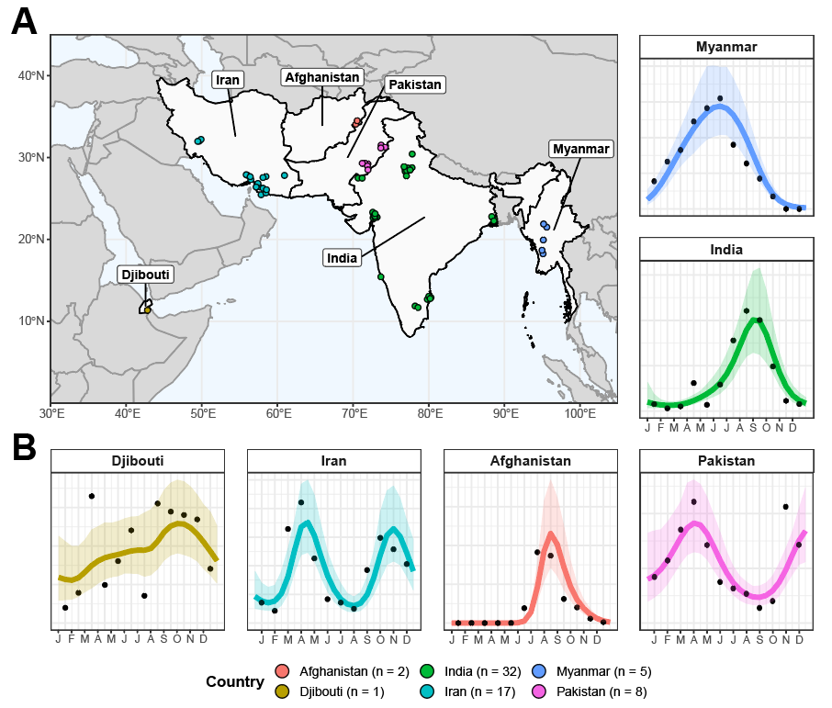

**Figure 1: Sources and Locations of *Anopheles stephensi* Time-Series Data and Examples for Each Country. (A)** Map of the geographical range over which collated time-series had been carried out in, with countries where studies had been carried out in highlighted in light grey, and the locations of individual studies indicated by points, coloured according to the country they were carried out in (Afghanistan = red, Djibouti = yellow, India = green, Iran = turquoise, Myanmar = blue and Pakistan = pink). **(B)** Example *Anopheles stephensi* time-series from each country, with the empirical monthly mosquito catch (black points) and fitted gaussian process curves (mean = coloured line, ribbon = 95% Bayesian Credible Interval) for each, coloured according to country. The x-axis indicates the month of sampling, the y-axis normalised annual vector density (i.e. arbitrary units).

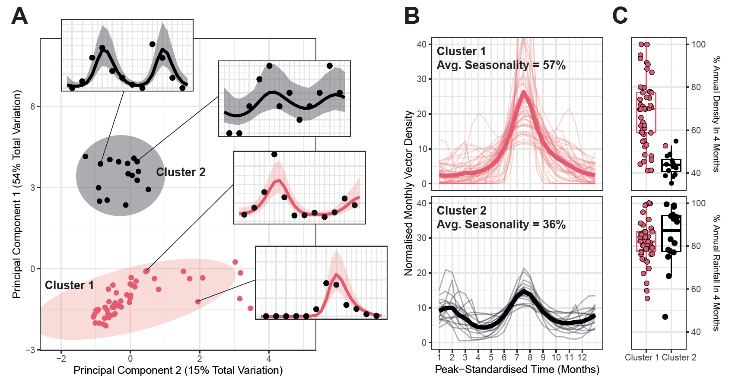

**Figure 2: Characterisation and Clustering to Identify Time-Series with Similar Temporal Properties. (A)** Results of principal components analysis (PCA) and k-means clustering for 2 clusters. Points indicate individual time-series, with point colour indicating cluster membership. Ellipsoids demarcate the 75th quantile of the density associated with each cluster. Principal components 1 and 2 are plotted, together explaining 69% of the total variation in temporal properties across the time-series. **(B)** Time-series belonging to each cluster. Pale lines represent individual time-series, brighter line the mean of all the time-series belonging to that cluster – in all cases vector density is normalised to sum to 1 over the course of the year, and time-standardised so that the highest vector density for each time-series is arbitrarily set to occur at month 7. **(C)** Boxplots of the percentage of annual total mosquito catch (top) and annual total rainfall (bottom) for each time-series. Rainfall data comes from the *CHIRPS* dataset37 and is specific to study location and time-period. Each point indicates an individual time-series.

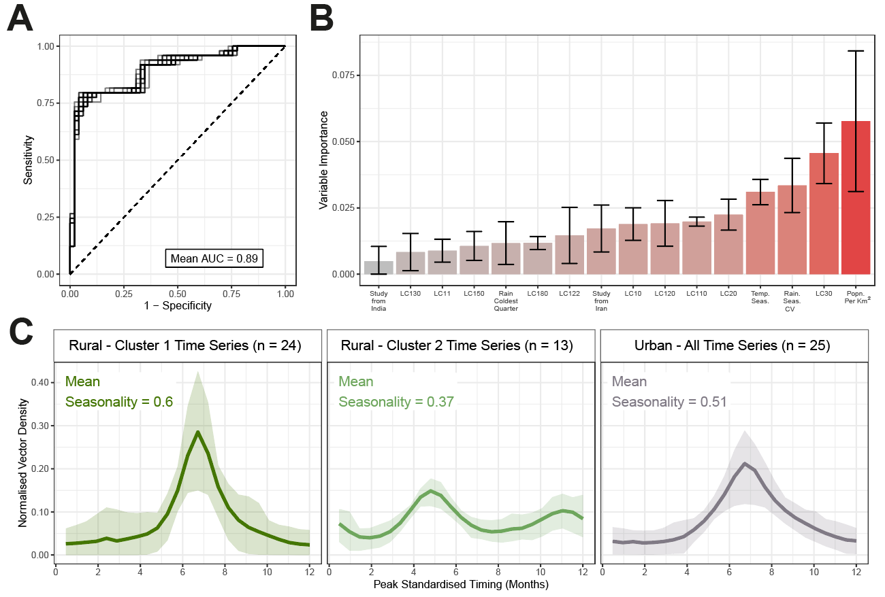

**Figure 3: Random Forest Prediction of Temporal Cluster Membership.** A random forest-based classification modelling framework was used to predict membership of the temporal cluster (either Cluster 1 or Cluster 2, as defined in **Fig 2)** and explore the ecological factors underpinning variation in *Anopheles stephensi* seasonality. **(A)** Receiver-operator curve (ROC) for each of the 25 individual iterations of random forest model fitting carried out, with results for each displayed as grey lines. The mean AUC across these 25 iterations was 0.89. **(B)** Variable importance plot for the covariates included in the random forest model – bar height indicates the mean variable importance across the 25 individual iterations of random forest fitting, with error bars representing the 95% confidence interval. **(C)** Collated *Anopheles stephensi* time-series, disaggregated according to urbanicity and cluster membership. Cluster 1 and Cluster 2 time-series from rural locations are plotted separately; all time series for time-series carried out in urban locations (22 belonging to Cluster 1 and only 3 belonging to Cluster 2) are plotted together. Coloured line indicates the mean and ribbon indicates the 90% range spanned by the group of time series belonging to each displayed grouping.

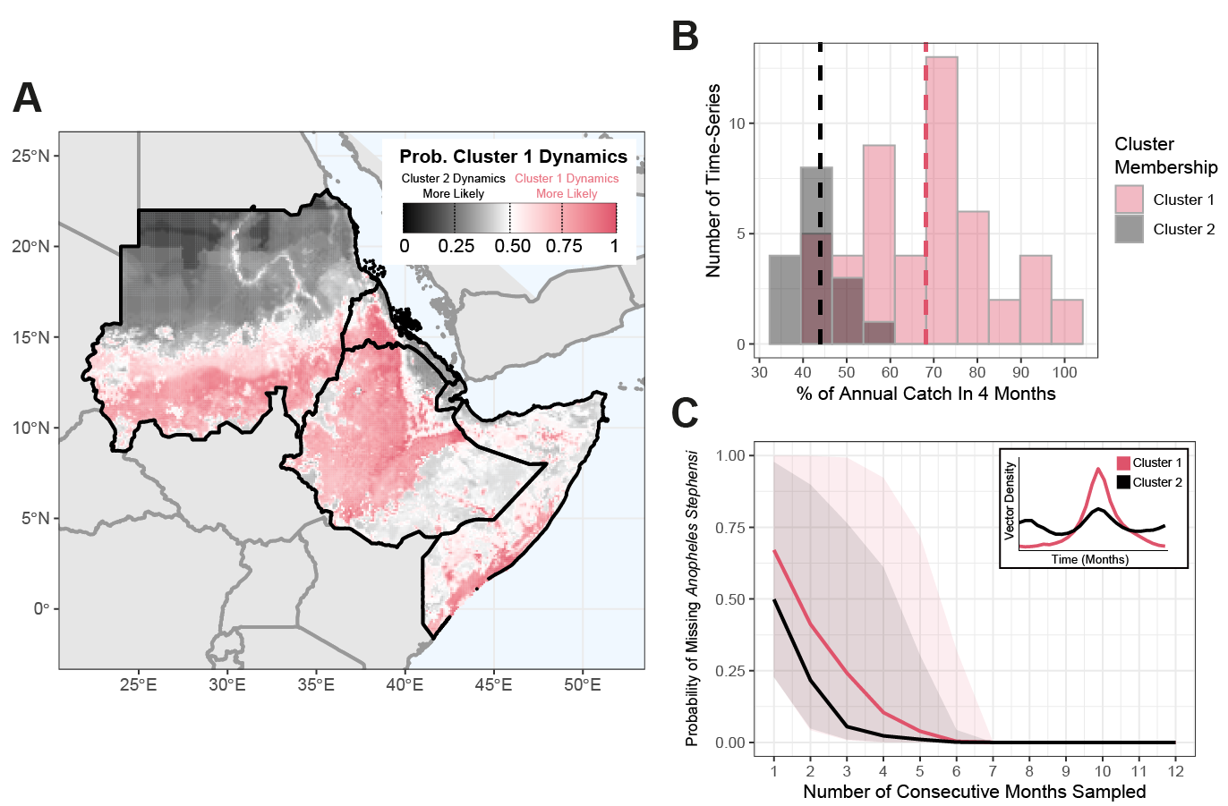

**Figure 4: Predicting the Possible Seasonal Dynamics of *Anopheles stephensi* Across the Horn of Africa. (A)** Environmental covariates were collated across countries in the Horn of Africa where *Anopheles stephensi* has been found, and the fitted random forest classification model from **Fig 3** used to predict potential temporal dynamics. Map shows the probability of temporal dynamics belonging to Cluster 1, with pink corresponding to Cluster 1 dynamics being more likely than Cluster 2, black indicating Cluster 2 dynamics are more likely than those for Cluster 1, and white indicating both are equally likely. **(B)** Histogram of the percentage of total annual catch in any continuous 4-month period for each time-series, coloured according to the cluster the time-series belong to. **(C)** The probability of missing *Anopheles stephensi* in an entomological catch survey (y-axis) as a function of the number of consecutive months randomly sampled, assuming the start-month is picked at random. Coloured lines are the mean results across all time-series belonging to each cluster, with the shaded area indicating the range spanned by all time-series belonging to each cluster.

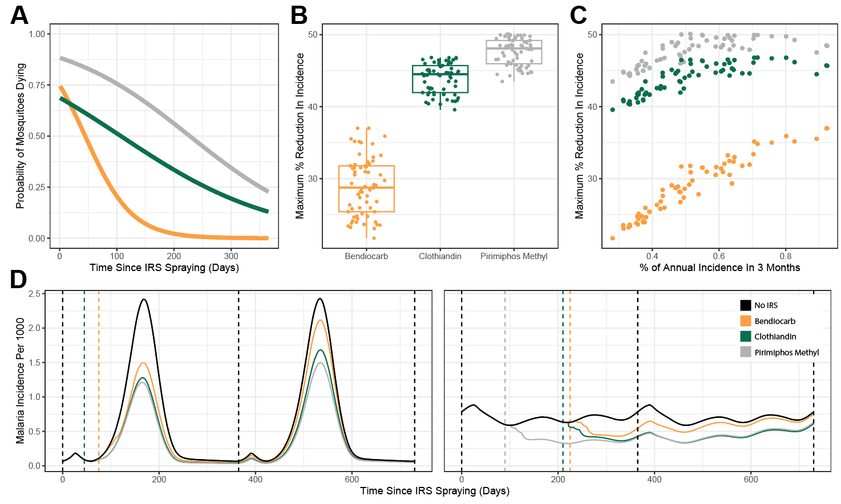

**Figure 5: Modelling the Public-Health Impact of Indoor Residual Spraying (IRS) and How This Is Impacted by *Anopheles stephensi* Seasonality. (A)** Probability of mosquitoes dying upon exposure to each IRS compound – yellow indicates bendiocarb, green indicates clothiandin and grey indicates pirimiphos methyl. **(B)** Percentage reduction in annual incidence (with optimal timing of IRS delivery), for each of the IRS compounds considered. Individual points correspond to specific time-series. **(C)** The relationship between percentage reduction in annual malaria incidences and the overall seasonality of malaria incidence in the setting (as modelled and implied by each *Anopheles stephensi* temporal profile). **(D)** Malaria incidence modelling results for a highly seasonal (left) and less seasonal (right) setting. Black lines indicate endemic dynamics in the absence of any IRS, coloured solid lines indicate incidence following a single IRS round (with timing of the round indicated by the coloured dashed lines).

**References**

1. Organization, W. H. & Others. World malaria report 2021. (2021).

2. Vos, T. *et al.* Global burden of 369 diseases and injuries in 204 countries and territories, 1990–2019: a systematic analysis for the Global Burden of Disease Study 2019. *Lancet* **396**, 1204–1222 (2020).

3. Malaria. https://www.who.int/news-room/fact-sheets/detail/malaria.

4. Bhatt, S. *et al.* The effect of malaria control on Plasmodium falciparum in Africa between 2000 and 2015. *Nature* **526**, 207–211 (2015).

5. Nations, U. Revision of world urbanization prospects. *United Nations: New York, NY, USA* **799**, (2018).

6. Doumbe-Belisse, P. *et al.* Urban malaria in sub-Saharan Africa: dynamic of the vectorial system and the entomological inoculation rate. *Malar. J.* **20**, 364 (2021).

7. Robert, V. *et al.* Malaria transmission in urban sub-Saharan Africa. *Am. J. Trop. Med. Hyg.* **68**, 169–176 (2003).

8. Trape, J. F. & Zoulani, A. Malaria and urbanization in central Africa: the example of Brazzaville. Part III: Relationships between urbanization and the intensity of malaria transmission. *Trans. R. Soc. Trop. Med. Hyg.* **81 Suppl 2**, 19–25 (1987).

9. Killeen, G. F., Govella, N. J., Mlacha, Y. P. & Chaki, P. P. Suppression of malaria vector densities and human infection prevalence associated with scale-up of mosquito-proofed housing in Dar es Salaam, Tanzania: re-analysis of an observational series of parasitological and entomological surveys. *Lancet Planet Health* **3**, e132–e143 (2019).

10. De Silva, P. M. & Marshall, J. M. Factors contributing to urban malaria transmission in sub-saharan Africa: a systematic review. *J. Trop. Med.* **2012**, 819563 (2012).

11. Awolola, T. S., Oduola, A. O., Obansa, J. B., Chukwurar, N. J. & Unyimadu, J. P. Anopheles gambiae s.s. breeding in polluted water bodies in urban Lagos, southwestern Nigeria. *J. Vector Borne Dis.* **44**, 241–244 (2007).

12. Kasili, S. *et al.* Entomological assessment of the potential for malaria transmission in Kibera slum of Nairobi, Kenya. *J. Vector Borne Dis.* **46**, 273–279 (2009).

13. Weiss, D. J. *et al.* Global maps of travel time to healthcare facilities. *Nat. Med.* **26**, 1835–1838 (2020).

14. Romeo-Aznar, V., Paul, R., Telle, O. & Pascual, M. Mosquito-borne transmission in urban landscapes: the missing link between vector abundance and human density. *Proc. Biol. Sci.* **285**, (2018).

15. Mourou, J.-R. *et al.* Malaria transmission in Libreville: results of a one year survey. *Malar. J.* **11**, 40 (2012).

16. Wang, S.-J. *et al.* Rapid Urban Malaria Appraisal (RUMA) IV: epidemiology of urban malaria in Cotonou (Benin). *Malar. J.* **5**, 45 (2006).

17. Klinkenberg, E., McCall, P., Wilson, M. D., Amerasinghe, F. P. & Donnelly, M. J. Impact of urban agriculture on malaria vectors in Accra, Ghana. *Malar. J.* **7**, 151 (2008).

18. Organization, W. H. & Others. Global technical strategy for malaria 2016-2030. 2021 update. *World Health Organization: Geneva* (2021).

19. Subbarao, S. K., Vasantha, K., Adak, T., Sharma, V. P. & Curtis, C. F. Egg-float ridge number in Anopheles stephensi: ecological variation and genetic analysis. *Med. Vet. Entomol.* **1**, 265–271 (1987).

20. Manouchehri, A. V., Javadian, E., Eshighy, N. & Motabar, M. Ecology of Anopheles stephensi Liston in southern Iran. *Trop. Geogr. Med.* **28**, 228–232 (1976).

21. Batra, C. P., Adak, T., Sharma, V. P. & Mittal, P. K. Impact of urbanization on bionomics of An. culicifacies and An. stephensi in Delhi. *Indian J. Malariol.* **38**, 61–75 (2001).

22. Thomas, S. *et al.* Overhead tank is the potential breeding habitat of Anopheles stephensi in an urban transmission setting of Chennai, India. *Malar. J.* **15**, 274 (2016).

23. Kumar, A. & Thavaselvam, D. Breeding habitats and their contribution to Anopheles stephensi in Panaji. *Indian J. Malariol.* **29**, 35–40 (1992).

24. Faulde, M. K., Rueda, L. M. & Khaireh, B. A. First record of the Asian malaria vector Anopheles stephensi and its possible role in the resurgence of malaria in Djibouti, Horn of Africa. *Acta Trop.* **139**, 39–43 (2014).

25. Balkew, M. *et al.* Geographical distribution of Anopheles stephensi in eastern Ethiopia. *Parasit. Vectors* **13**, 35 (2020).

26. Tadesse, F. G. *et al.* Anopheles stephensi Mosquitoes as Vectors of Plasmodium vivax and falciparum, Horn of Africa, 2019. *Emerg. Infect. Dis.* **27**, 603–607 (2021).

27. Ahmed, A. *et al.* Invasive malaria vector anopheles stephensi mosquitoes in Sudan, 2016-2018. *Emerg. Infect. Dis.* **27**, 2952–2954 (2021).

28. Ahmed, A., Khogali, R., Elnour, M.-A. B., Nakao, R. & Salim, B. Emergence of the invasive malaria vector Anopheles stephensi in Khartoum State, Central Sudan. *Parasit. Vectors* **14**, 511 (2021).

29. Sinka, M. E. *et al.* A new malaria vector in Africa: Predicting the expansion range of Anopheles stephensi and identifying the urban populations at risk. *Proc. Natl. Acad. Sci. U. S. A.* **117**, 24900–24908 (2020).

30. Hamlet, A. *et al.* The potential impact of Anopheles stephensi establishment on the transmission of Plasmodium falciparum in Ethiopia and prospective control measures. *bioRxiv* (2021) doi:10.1101/2021.08.19.21262272.

31. Feachem, R. G. A. *et al.* Malaria eradication within a generation: ambitious, achievable, and necessary. *Lancet* **394**, 1056–1112 (2019).

32. ACCESS-SMC Partnership. Effectiveness of seasonal malaria chemoprevention at scale in west and central Africa: an observational study. *Lancet* **396**, 1829–1840 (2020).

33. Tukei, B. B., Beke, A. & Lamadrid-Figueroa, H. Assessing the effect of indoor residual spraying (IRS) on malaria morbidity in Northern Uganda: a before and after study. *Malar. J.* **16**, 4 (2017).

34. Whittaker, C. *et al.* The ecological structure of mosquito population seasonal dynamics. *bioRxiv* (2021) doi:10.1101/2021.01.09.21249456.

35. Carpenter, B. *et al.* Stan: A probabilistic programming language. *J. Stat. Softw.* **76**, 1–32 (2017).

36. Fulcher, B. D., Little, M. A. & Jones, N. S. Highly comparative time-series analysis: the empirical structure of time series and their methods. *J. R. Soc. Interface* **10**, 20130048 (2013).

37. Cairns, M. *et al.* Estimating the potential public health impact of seasonal malaria chemoprevention in African children. *Nat. Commun.* **3**, 881 (2012).

38. Fick, S. E. & Hijmans, R. J. WorldClim 2: new 1‐km spatial resolution climate surfaces for global land areas. *Int. J. Climatol.* **37**, 4302–4315 (2017).

39. Wright, M. N. & Ziegler, A. ranger: A Fast Implementation of Random Forests for High Dimensional Data in C++ and R. *arXiv [stat.ML]* (2015).

40. Kuhn, M. & Wickham, H. Tidymodels: a collection of packages for modeling and machine learning using tidyverse principles. *Boston, MA, USA. [(accessed on 10 December 2020)]* (2020).

41. Chawla, N. V., Bowyer, K. W., Hall, L. O. & Kegelmeyer, W. P. SMOTE: Synthetic Minority Over-sampling Technique. *J. Artif. Intell. Res.* **16**, 321–357 (2002).

42. Griffin, J. T., Ferguson, N. M. & Ghani, A. C. Estimates of the changing age-burden of Plasmodium falciparum malaria disease in sub-Saharan Africa. *Nat. Commun.* **5**, 3136 (2014).

43. Challenger, J. D. *et al.* Predicting the public health impact of a malaria transmission-blocking vaccine. *Nat. Commun.* **12**, 1494 (2021).

44. Griffin, J. T. *et al.* Reducing Plasmodium falciparum malaria transmission in Africa: a model-based evaluation of intervention strategies. *PLoS Med.* **7**, e1000324 (2010).

45. Beck-Johnson, L. M. *et al.* The importance of temperature fluctuations in understanding mosquito population dynamics and malaria risk. *R Soc Open Sci* **4**, 160969 (2017).

46. Mordecai, E. A. *et al.* Thermal biology of mosquito-borne disease. *Ecol. Lett.* **22**, 1690–1708 (2019).

47. Killeen, G. F., Fillinger, U., Kiche, I., Gouagna, L. C. & Knols, B. G. J. Eradication of Anopheles gambiae from Brazil: lessons for malaria control in Africa? *Lancet Infect. Dis.* **2**, 618–627 (2002).

48. Enayati, A., Hanafi-Bojd, A. A., Sedaghat, M. M., Zaim, M. & Hemingway, J. Evolution of insecticide resistance and its mechanisms in Anopheles stephensi in the WHO Eastern Mediterranean Region. *Malar. J.* **19**, 258 (2020).

49. Safi, N. H. Z. *et al.* Status of insecticide resistance and its biochemical and molecular mechanisms in Anopheles stephensi (Diptera: Culicidae) from Afghanistan. *Malar. J.* **18**, 249 (2019).

50. Vatandoost, H. & Hanafi-Bojd, A. A. Indication of pyrethroid resistance in the main malaria vector, Anopheles stephensi from Iran. *Asian Pac. J. Trop. Med.* **5**, 722–726 (2012).

51. Ali Khan, H. A., Akram, W. & Lee, S. Resistance to Selected Pyrethroid Insecticides in the Malaria Mosquito, Anopheles stephensi (Diptera: Culicidae), From Punjab, Pakistan. *J. Med. Entomol.* **55**, 735–738 (2018).

52. Tiwari, S., Ghosh, S. K., Ojha, V. P., Dash, A. P. & Raghavendra, K. Reduced susceptibility to selected synthetic pyrethroids in urban malaria vector Anopheles stephensi: a case study in Mangalore city, South India. *Malar. J.* **9**, 179 (2010).

53. Yared, S. *et al.* Insecticide resistance in Anopheles stephensi in Somali Region, eastern Ethiopia. *Malar. J.* **19**, 180 (2020).

54. Balkew, M. *et al.* An update on the distribution, bionomics, and insecticide susceptibility of Anopheles stephensi in Ethiopia, 2018-2020. *Malar. J.* **20**, 263 (2021).

55. Massey, N. C. *et al.* A global bionomic database for the dominant vectors of human malaria. *Sci. Data* **3**, 160014 (2016).

56. Sherrard-Smith, E. *et al.* Mosquito feeding behavior and how it influences residual malaria transmission across Africa. *Proc. Natl. Acad. Sci. U. S. A.* **116**, 15086–15095 (2019).

57. Nagpal, B. N., Srivastava, A., Kalra, N. L. & Subbarao, S. K. Spiracular indices in Anopheles stephensi: a taxonomic tool to identify ecological variants. *J. Med. Entomol.* **40**, 747–749 (2003).

58. Chavshin, A. R. *et al.* Molecular characterization, biological forms and sporozoite rate of Anopheles stephensi in southern Iran. *Asian Pac. J. Trop. Biomed.* **4**, 47–51 (2014).